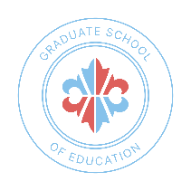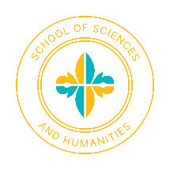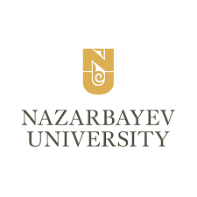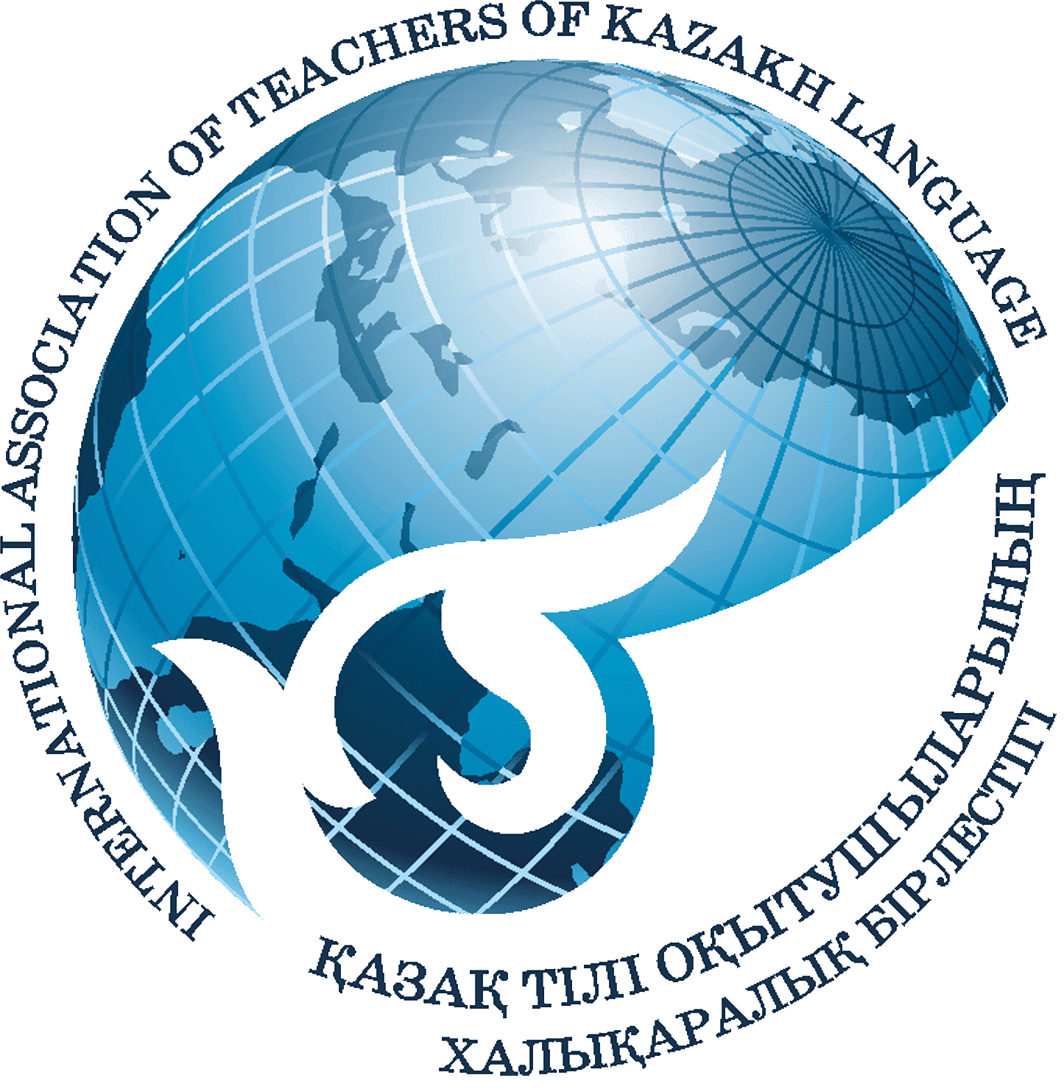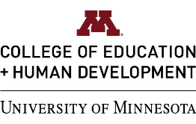

**Information Letter**

Nazarbayev University in cooperation with the University of Minnesota (USA) invites you to take part in the International Scientific Symposium on the topic: **"Modern Trends in Education and Language Learning"**, which will be held on **October 17, 2023**, in Astana, at Nazarbayev University.

**Purpose of the Symposium:** By uniting scholars, researchers, and scientists, the symposium aims to tackle current trends and shared challenges within the realm of education and language instruction. Through contributions from scholars offering distinct viewpoints and a deep understanding of pertinent subjects, including the influence of technology in education, variations in approaches due to cultural and geographical factors, recent advancements in language instruction techniques, and other relevant areas, this academic event provides unparalleled prospects for uncovering novel concepts. Moreover, attendees can engage in thought-provoking discussions with colleagues, while also showcasing their research findings to an engaged audience of fellow scientists and researchers.

**Working directions of the symposium:**

1. Leadership, Management, and Internationalization in education
2. Educational research and innovative technologies
3. Language Policy, Linguistic Diversity, and Multilingualism
4. Artificial Intelligence and the Future of Language Education

In the symposium will be conducted a round table discussion on "*Modern Trends in Education and Language Learning*".

**Symposium languages:** Kazakh, Russian, and English.

**Rules and deadlines for registration for the symposium:** Application for participation in the symposium and abstracts of the article **until October 8, 2023,** by e-mail [symposium@nu.edu.kz](mailto:symposium@nu.edu.kz)

The text of the application is attached in ***Appendix 1***.

**Conference formats and duration of reports:**

**-** Plenary meeting / for each 15-20 minutes /

- Section / for each - 15 min. /

- Panel discussions, colloquia / for 2-3 people - 30 minutes /

**Requirements for the formulation of abstracts**: the length of abstracts is 250-300 words. The text should be prepared in MS Word format, Times New Roman font, size 12, interval 1, paragraph 1.25 cm, 2 cm on all sides, with 4-5 keywords attached at the end of the text.

**Conditions of participation:** transport, hotel, and other travel expenses are paid by the participant.

Registration fees for the conference is **Free.**

**Organizing Committee:** 010000, Republic of Kazakhstan, Astana, Kabanbai Batyr Avenue 53, 8-block, School of Humanitarian and Social Sciences, 2-floor. Phones for communication: +7-717270-59-25. Mob. +77787432045 Zeinep Zhumatayeva

E-mail: [symposium@nu.edu.kz](mailto:symposium@nu.edu.kz)

**Organizing Committee**

***Appendix 1***

**APPLICATION**

Participant in the international scientific symposium

**"Modern Trends in Education and Language Learning"**

|  |  |
| --- | --- |
| *Surname* |  |
| *Name* |  |
| *Middle name* |  |
| *Scientific degree, title* |  |
| *Place of work* |  |
| *Position* |  |
| *Address* |  |
| *Work phone* |  |
| *Cellular phone* |  |
| *Email* |  |
| *Section name (working directions of the conference)* |  |
| *Title of the report* |  |
| *Visa support* | *is needed / not needed* |